**Overview of the Key Prop**

The key prop is used to uniquely identify elements in a list, helping React distinguish between multiple instances of the same component type. It ensures elements have a stable identity across renders or helps reset component state when necessary.

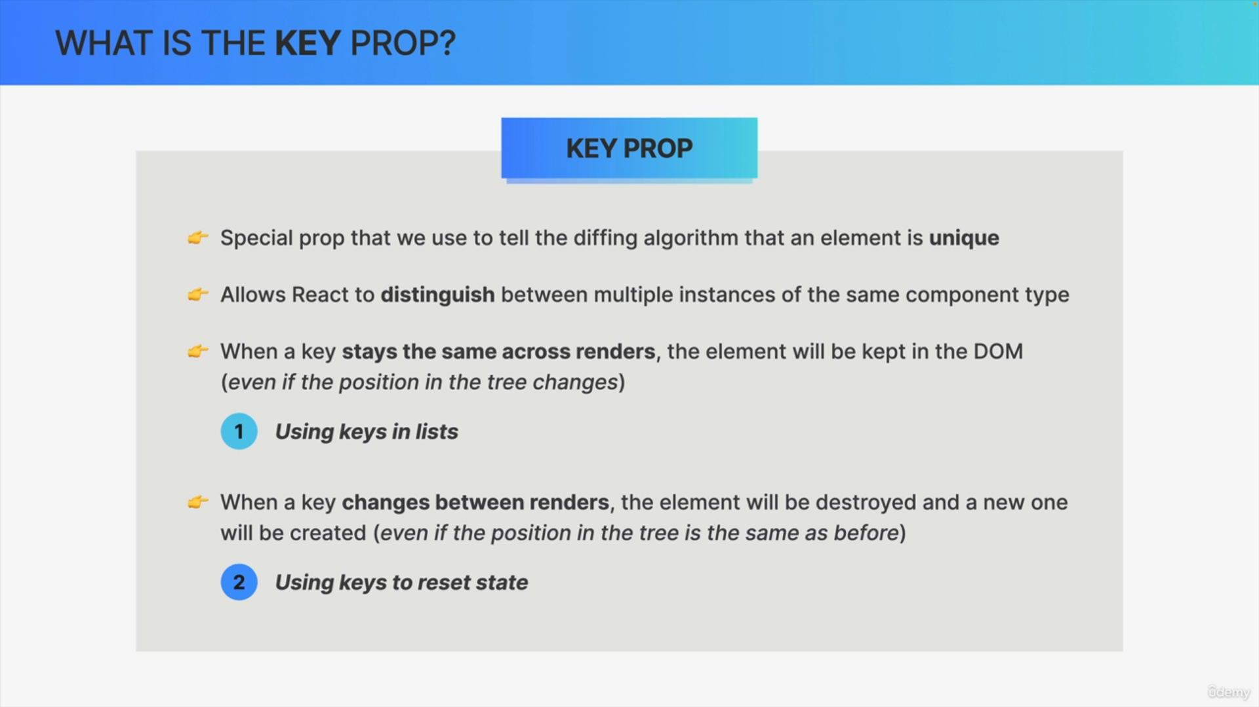

**Why the Key Prop is Needed**

**Stable Keys**

* Elements with stable keys are kept in the DOM, even if their position in the tree changes.
* This prevents unnecessary removal and recreation of elements, enhancing performance.
* Example: In a list, adding a new item at the top without keys causes existing items to be removed and recreated. With keys, the items are repositioned without removal, preserving their state.

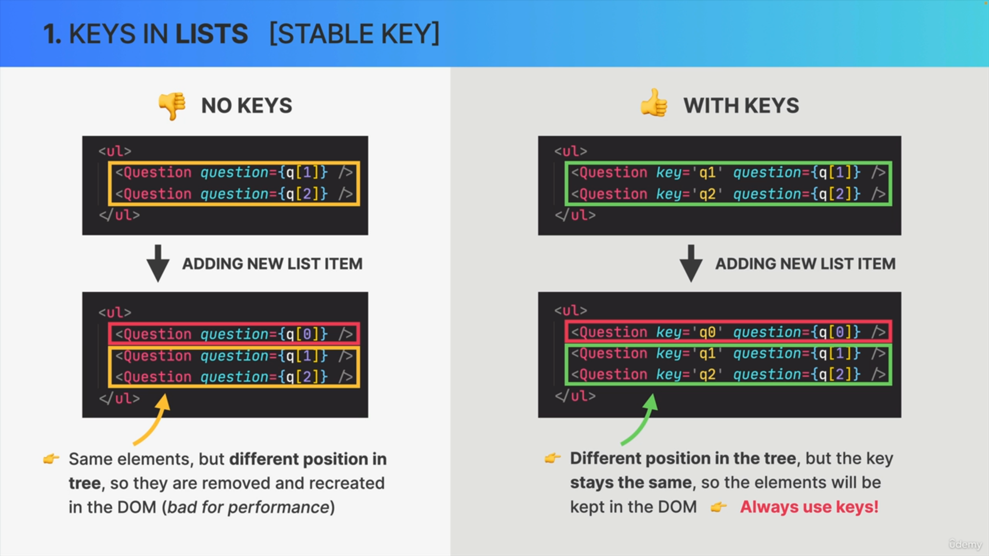

**Changing Keys**

* Elements with changing keys are treated as new instances, causing React to destroy the old element and create a new one.
* This is useful for resetting component state.
* Example: Changing the key of a component resets its state, which is useful when the component's props change in a way that makes the current state irrelevant.





**Practical Use Cases**

**Lists**

* Always use the key prop for elements in a list to avoid React warnings and improve performance, especially for large lists.
* Example: Assign unique keys to list items to maintain their identity across renders.

**State Reset**

* Use changing keys to reset the state of a component when its props change significantly.
* Example: When a component's question prop changes, assigning a new key ensures the component state is reset, displaying the appropriate answer for the new question.

**Summary**

1. Stable Keys: Prevent unnecessary re-renders by maintaining element identity.
2. Changing Keys: Allow state reset by treating elements as new instances.
3. Best Practices: Always use keys in lists and change keys to reset state when needed.